IV Semester BCA 2025
Artificial Intelligence LAB

PART - A
- Write a Program to implement Breadth First Search using Python.
- Write a Program to implement Depth First Search using Python.
- Write a Program to implement Best First Search using Python.
- Write to implement a Program Water Jug problem using Python.
- Write a Program to implement Tower of Hanoi using Python.

PART – B
- Write a Program to implement Travelling Salesmen Problem using Python.
- Write a Program to implement 8 Puzzle Problem using Python.
- Write a Program to implement Latin Square Problem using Python.
- Write a Program to solve Rat in a Maze using Backtracking using Python.
- Write a Program to Solve Graph Coloring problem using Python.

Program 01: Write a Program to implement Breadth First Search using Python.
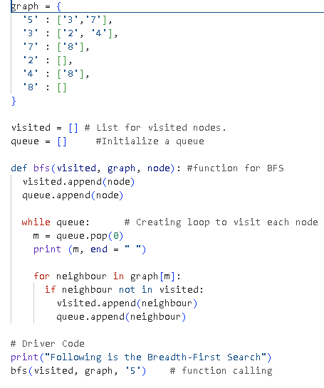
Output:
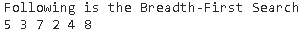

Program 02: Write a Program to implement Depth First Search using Python.
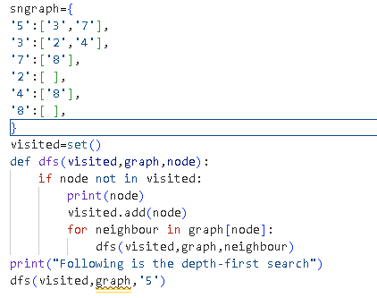
Output:
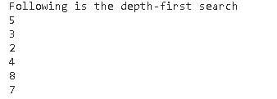
Program 03: Write a Program to implement Best First Search using Python.
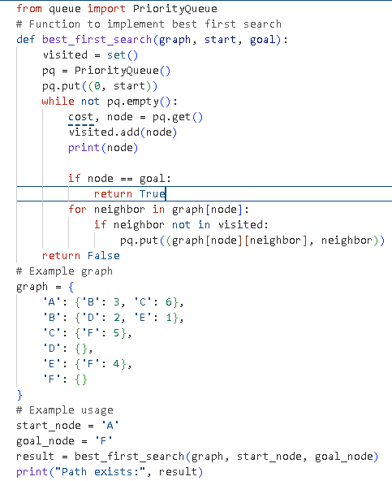
Output:
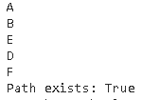

Program 04: Write to implement a Program Water Jug problem using Python.
# This function is used to initialize the
# dictionary elements with a default value.
from collections import defaultdict

# jug1 and jug2 contain the value
# for max capacity in respective jugs
# and aim is the amount of water to be measured.
jug1, jug2, aim = 4, 3, 2

# Initialize dictionary with
# default value as false.
visited = defaultdict(lambda: False)

# Recursive function which prints the
# intermediate steps to reach the final
# solution and return boolean value
# (True if solution is possible, otherwise False).
# amt1 and amt2 are the amount of water present
# in both jugs at a certain point of time.
def waterJugSolver(amt1, amt2):

# Checks for our goal and
# returns true if achieved.
if (amt1 == aim and amt2 == 0) or (amt2 == aim and amt1 == 0):
print(amt1, amt2)
return True

# Checks if we have already visited the
# combination or not. If not, then it proceeds further.
if visited[(amt1, amt2)] == False:
print(amt1, amt2)

# Changes the boolean value of
# the combination as it is visited.
visited[(amt1, amt2)] = True

# Check for all the 6 possibilities and
# see if a solution is found in any one of them.
return (waterJugSolver(0, amt2) or
waterJugSolver(amt1, 0) or
waterJugSolver(jug1, amt2) or
waterJugSolver(amt1, jug2) or
waterJugSolver(amt1 + min(amt2, (jug1-amt1)),
amt2 - min(amt2, (jug1-amt1))) or
waterJugSolver(amt1 - min(amt1, (jug2-amt2)),
amt2 + min(amt1, (jug2-amt2))))

# Return False if the combination is
# already visited to avoid
# already visited to avoid repetition otherwise
# recursion will enter an infinite loop.
else:
return False

print("Steps: ")

# Call the function and pass the
# initial amount of water present in both jugs.
waterJugSolver(0, 0)

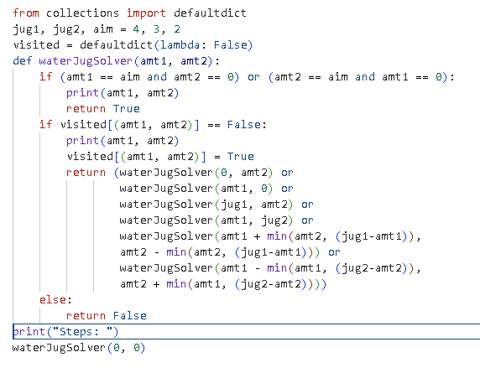
Output:
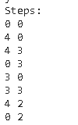
Program 5: Write a Program to implement Tower of Hanoi using Python without user input.
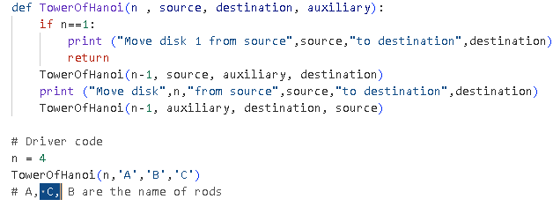
Output:
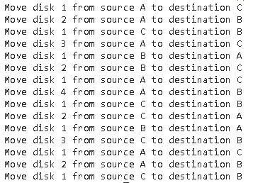

Program 5: Write a Program to implement Tower of Hanoi using Python with user input.
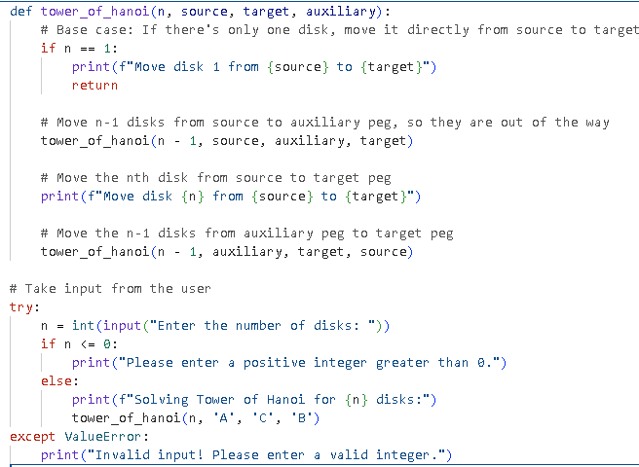
Output:
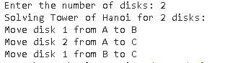

Program 6: Write a Program to implement Travelling Salesmen Problem using Python.
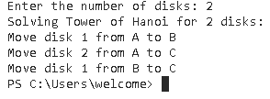

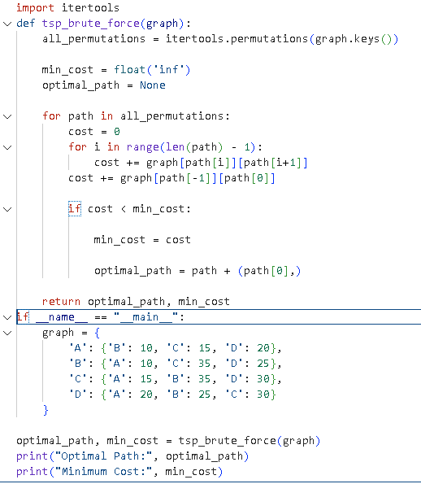
Output:
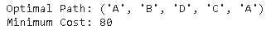

7. Write a Program to implement 8 Puzzle Problem using Python.
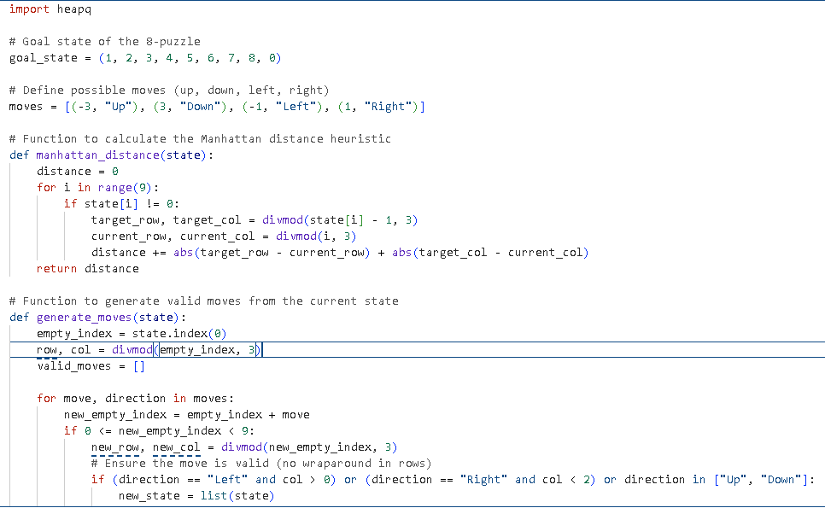
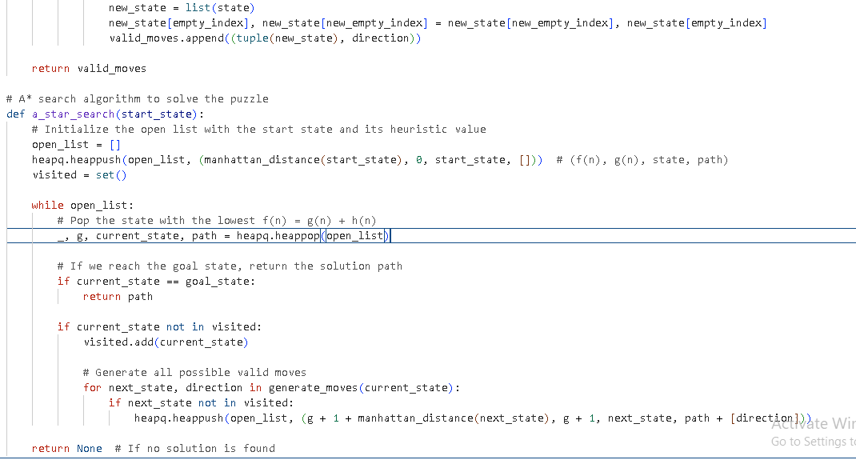
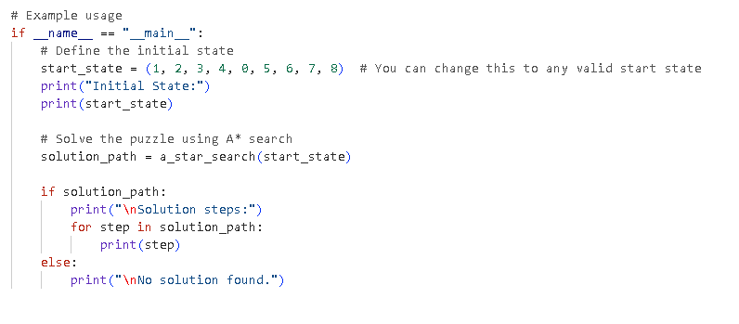
Output:
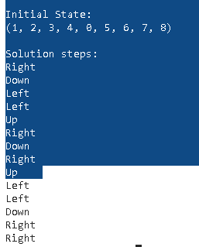

PROGRAM 08: Write a Program to implement Latin Square Problem using Python

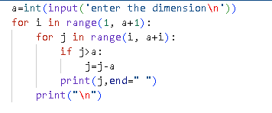
Output:
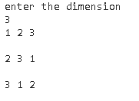

Program 09: Write a Program to solve Rat in a Maze using Backtracking using Python
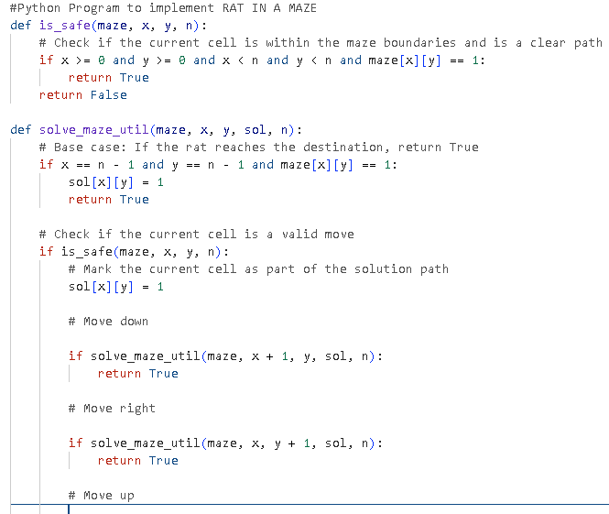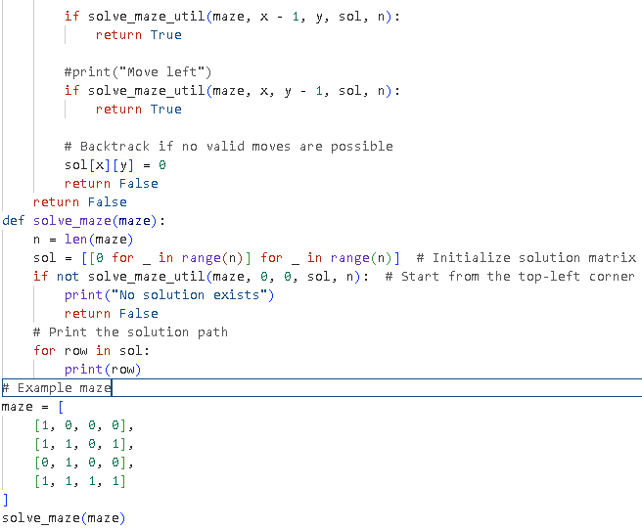
Program 09 Output:
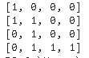

Program 10: Write a Program to Solve Graph Coloring problem using Python.
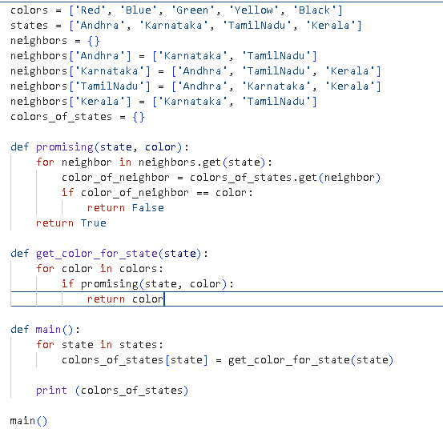

OUTPUT:

